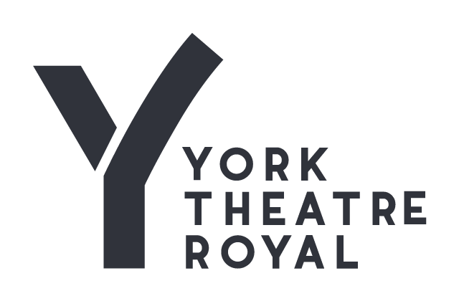
Inclusion and Diversity Monitoring
York Theatre Royal is committed to promoting theatre for all. By providing this information you are helping us to achieve equality in the arts. By working together we can open up opportunities for everyone.

Any information you supply will be treated in the strictest confidence, it will not be shared with anyone without being anonymised. It will only be used for monitoring and reporting.

On receipt, this section will be detached from the main body of the application form and will
not form any part of the selection process.

Please tick the option that best describes you.

- What best describes your gender? If you prefer to self-describe, please use the other answer option

Female (including trans women)

Male (including trans men)

Non-binary

Prefer not to say

- Is your gender identity the same as the sex you were assigned at birth?

Yes

No

Prefer not to say

- How old are you?

0 – 19

20 – 34

35 – 49

50 – 64

65 – 74

75+

Prefer not to say

- What best describes your sexual orientation? If you would prefer to self-describe, please use the other answer option.

Bisexual

Gay man

Gay woman / lesbian

Heterosexual / straight

Queer or none of the above

Prefer not to say

- Do you identify as having a disability?

Yes

No

Prefer not to say

- Do you identify as neuro-divergent?

Yes

No

Prefer not to say

- What is your ethnicity?

White – British

White – Irish

White – Gypsy or Irish Traveller

White – any other background

Mixed – White and Black Caribbean

Mixed – White and Black African

Mixed – White and Asian

Mixed – any other background

Asian / Asian British – Indian

Asian / Asian British – Pakistani

Asian / Asian British – Bangladeshi

Asian / Asian British – Chinese

Asian / Asian British – any other background

Black / Black British – African

Black / Black British – Caribbean

Latin American

Black / Black British – any other background

Arab

Any other ethnic group

Prefer not to say

Thank you

