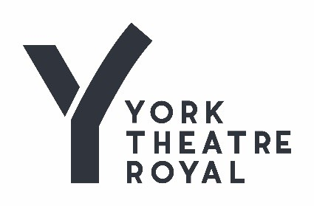
Dear Applicant,

Thank you for your interest in the role of Stage Technician. This is a freelance, fixed term contract for services, which require candidates to have self-employed status.

Stage Technician for The Railway Children by Mike Kenny and directed by Damian Cruden
Contract start date: 30 June 2025
Contract finish date: 12 September 2025

The fee for services is £550.00 per week. All other T&C’s as per the YTR / BECTU house agreement.

To express an interest please send your CV and a covering letter to jobs@yorktheatreroyal.co.uk by Tuesday 13 May 2025. Interviews will take place on Thursday 15 May 2025.

The Railway Children is part of the Bradford City of Culture celebrations. It is a co production between Bradford 2025, the Keighley and Worth Valley Railway and York Theatre Royal. It is taking place at Oxenhope Railway Station on the Keighley and Worth Vallet Railway where the original Railway Children film was shot. The audience will travel to the theatre by steam train.

York Theatre Royal
York Theatre Royal is one of the region’s most successful producing theatres welcoming more than 185,000 visitors each year to a unique 280 year old building in the heart of the beautiful and historic city of York - www.visityork.org.
Supported by Arts Council England and City of York Council, the Theatre Royal provides an exciting mixed programme of work in our 760 seat main house, 70 seat Studio Theatre and in amazing site specific locations throughout the city and beyond. We have an international reputation for the outstanding quality of our own produced work, as well as long standing partnerships with many other creative organisations including Wise Children. We also welcome a range of the country’s leading touring companies to York including Ballet Black and English Touring Opera to offer a different perspective to our audiences – www.yorktheatreroyal.co.uk.
York Theatre Royal has an outstanding track record of community engagement, developed and delivered over many years. We are very proud of our innovative, far-reaching and proactive projects that celebrate creativity in our community. We are ambitious to extend our reach and enable more people to live creative and fulfilling lives.
About Bradford 2025
Bradford 2025 UK City of Culture (Bradford 2025) runs from January 2025 to December 2025 and is a celebration of Bradford city and district, taking place across its city, towns, villages and greenspaces. It will showcase the rich history of the area and spotlight its dynamic contemporary culture in all forms, dance and theatre, music and film, visual arts and crafts, food and sport.
The City of Culture designation has already brought significant investment to the region and been a catalyst for development. It is set to have a lifelong impact through its reshaping of the local curriculum, skills and training programmes, investment in existing and new creative spaces, and open up opportunities for cultural participation.
You can find out more about Bradford 2025 on our website.
The Railway Children
Mike Kenny’s enchanting stage adaptation of E. Nesbit’s classic novel has won thousands of admirers since it premiered in 2008. Now, for the first time, we’re taking this production for a ride along the iconic Keighley & Worth Valley Railway, familiar to millions from the film adaptation of The Railway Children. Exclusively for Bradford 2025, the show begins when audiences board a steam train at Keighley, then travel the full length of this historic railway. When they reach the end of the line at Oxenhope, audiences will find a purpose-built auditorium within the station’s Engine Shed – and a new version of the production, directed by Damian Cruden, which tells the story of three children forced to move from London to Yorkshire after their father is falsely imprisoned.
Work Permits
Under the Asylum and Immigration Act, we are required to check that anyone taking up employment with us has the legal right to work in the UK. Successful applicants may be asked to provide us with documentary evidence to support their entitlement to work in the UK prior to taking up employment.
In the event of an offer of employment being made, we will take up references and reserve the right to validate all information entered on this form.
If you have any questions or would like any assistance, please don’t hesitate to contact us at jobs@yorktheatreroyal.co.uk
Good luck with your application
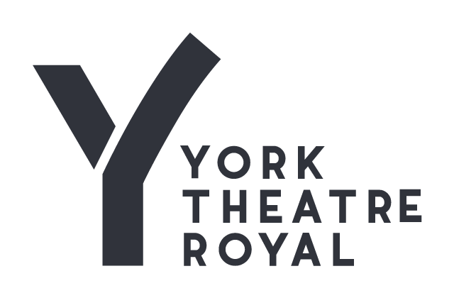
PERSON SPECIFICATION
The following represents the essential and desirable attributes for the role of Stage Technician:

Essential How Identified

A good knowledge and understanding of technical
stage management and the production process Application & Interview

Experience of Get-ins / Fit-ups and Get-outs Application & Interview

Experience of working as part of a stage crew Application & Interview
Basic Carpentry skills Application & Interview
A good knowledge of Health & Safety legislation and
procedures and there implications in the theatre environment Application & Interview
An enthusiastic and energetic approach, a positive mental
attitude and fresh ideas which match the ambitions of the
organisation Application & Interview
A clear, systematic and flexible approach to work, with a
positive and supportive attitude to finding effective solutions
to problems Application & Interview

A co-operative manner with all staff and a friendly, tactful and
discreet approach to all situations Application & Interview
Team Player, who is self-motivated and able to work with
minimum supervision Application & Interview

A genuine interest in theatre Application & Interview

ROLE DESCRIPTION
The Stage Technician is an essential role for the production during the Tech and run of The Railway Children.
He/she works closely with the Head of Stage and plays a key role in ensuring the smooth running of the show.
He/she will work all performances of the show in order to ensure the production is presented to the highest possible standards.
He/she will assist the Head of Stage in ensuring all scenic elements remain in good working order, making or arranging appropriate repairs when required
He/she will make a positive contribution towards maintaining good working relationships between production departments
He/she will be contributing to the H&S and housekeeping in the working spaces.

