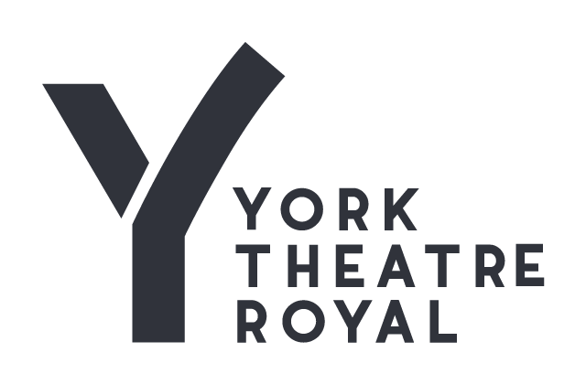
Dear Applicant,
Thank you for your interest in the post of Youth Theatre Practitioner (fixed term) for York Theatre Royal. These are freelance, fixed term contract for services, which require candidates to have self-employed status.
We are seeking a Youth Theatre Practitioner to deliver our Autumn term.
5-8 and 8-11’s Youth Theatre Practitioner
Saturday Youth Theatre sessions at York Theatre Royal - a 5-8 years and 8-11’s years group.
This fixed term contract is for 10 weeks from 27 Sept to 07 Dec 2025 (excluding w/c 27 Oct).
In addition, there will be a staff planning meeting on 12 Sept (4.30pm - 6.30pm), extra rehearsals on Sat 04 Oct, Sunday 23 Nov (both 2pm - 5pm), two 1hr production meetings (dates TBC), plot and tech day on Wed 10 Dec 4.30pm - 8.00pm and a performance day on 13 Dec 9.45am - 12.30pm.
Your completed application form needs to be posted or emailed to reach us by 5pm on Mon 21 July 2025.
Interviews will take place on 29 July.
York Theatre Royal has an outstanding track record of community engagement, developed and delivered over many years. We are very proud of our innovative, far reaching and proactive projects that celebrate creativity in our community. We are ambitious to extend our reach and enable more people to live creative and fulfilling lives.
York Theatre Royal
York Theatre Royal is one of the region’s most successful producing theatres welcoming more than 185,000 visitors each year to a unique 280 year old building in the heart of the beautiful and historic city of York - www.visityork.org.
Supported by Arts Council England and City of York Council, the Theatre Royal provides an exciting mixed programme of work in our 760 seat main house, 70 seat Studio Theatre and in amazing site specific locations throughout the city. We have an international reputation for the outstanding quality of our own produced work, as well as long standing partnerships with many other creative organisations including Wise Children and the RSC. We also welcome a range of the country’s leading touring companies to York including Ballet Black and English Touring Opera to offer a different perspective to our audiences – www.yorktheatreroyal.co.uk.

York Citizens’ Theatre Trust – Mission, Vision and Values
York Theatre Royal is a brave creative hub at the heart of the city, and it is here for you.
These stages, buildings and our city will thrive with live performance of exceptional quality made with you – the world’s most exciting artists – with more of the world’s most exciting artists.
Our Values
- We are ambitious, throughout the organisation
- We are sturdy
- We care about the climate
- We are welcoming
- We are ambassadors for York
- We celebrate the city’s true diversity: it makes us bloom
- We are creative in every context
- We pull together

York Theatre Royal is an organisation determined to:

- Be more innovative, far-reaching and pro-active in helping our entire community live creative lives
- Be organisationally robust in order that we might be ambitious, risk-taking and forward thinking
- Be admired locally and nationally as an inspirational city theatre for the post-pandemic era
- Be leaders on diversity in our community
- Acknowledge, in every aspect of our work, that climate change profoundly affects this community

For further information about York Theatre Royal please go to www.yorktheatreroyal.co.uk

Good luck with your applications

Person Specification 5-8 and 8-11’s Youth Theatre Practitioner

This position is to join our freelance team in delivering our two Saturday Youth Theatre sessions at York Theatre Royal; a 5-8 and 8-11’s group.

The following represents the essential and desirable attributes for the post of Youth Theatre Practitioner:

Essential How Identified

Candidates must be over 18 years of age Application

Ability to work a regular Saturday morning for the autumn term Application

Experience as a theatre practitioner with 5-11yr olds Application & Interview

Have directed a scripted Youth Theatre performance Application & Interview

Enthusiasm, imagination & drive with the ability to Application & Interview
motivate and inspire young people

Understanding of theatre technical skills & practice Application & Interview

Good communication and negotiation skills Application & Interview

Ability to use own initiative Application & Interview

Ability to work as part of a team Application & Interview

Knowledge of safeguarding practice Application & Interview

Must clear an enhanced DBS check
Desirable How Identified
Experiencing directing plays with songs Application & Interview
First Aid Certificate Application

Role Description

1. Job Title Youth Theatre Practitioner 5-8 and 8-11’s

-------------------------------------------------------------------------------------------------------------------------------------

2. Primary Objectives:

- To plan and lead as Practitioner on two Youth Theatre sessions.
- To direct the 8-11’s in their yearly production in our Studio theatre.
- To ensure the wellbeing and safety of the young people involved.
--------------------------------------------------------------------------------------------------------------------------

3. Location: York Theatre Royal

-------------------------------------------------------------------------------------------------------------------------

4. Supervisory responsibilities/position in structure:

Responsible to the Head of Youth Theatre

Responsible for assistants, mentors and volunteers

--------------------------------------------------------------------------------------------------------------------------

4. Main Duties:

- To plan and facilitate the 5-8’s YTR group. Agreeing broad termly content in advance with the Head of Youth Theatre, sending through workshop plans.
- To plan, facilitate and direct the 8-11’s YTR group, working towards a production.
- To attend two production meetings, working within the parameters of the production budget and the other 8-11’s Directors' visions to deliver a coherent and creative production.
- To accompany the Youth Theatre group on trips, if requested by the Head of Youth Theatre.
- To undertake any other duties which may be reasonably requested.
Terms and Conditions
This is a freelance contract for services.
- Contract runs for 10 weeks from 27 Sept to 07 Dec 2025 (excluding 01 November).

- In addition, there will be a staff planning meeting on 12 Sept (4.30pm - 6.30pm), extra rehearsals on Sat 04 Oct, Sun 23 Nov (both 2pm - 5pm), two 1hr production meetings (dates TBC), plot and tech day on Wed 10 Dec 4.30pm - 8.00pm and a performance day on 13 Dec 9.45am - 12.30pm.

- Fee £70 per session (£1,400 for both classes per term) plus £870 for meetings, additional rehearsals and tech week.

